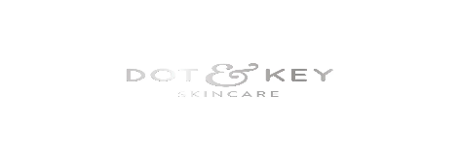
Dot & Key
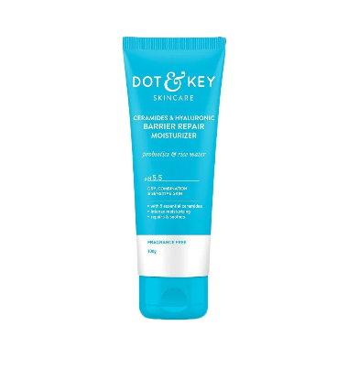
- Industry: D2C Skincare (India)

- Product: Barrier Repair Serum

- Target Audience: 18–30 years, sensitive / damaged skin barrier

- Primary Platform: Instagram Reels
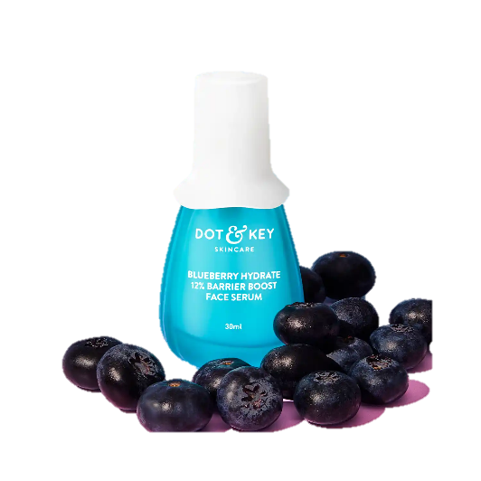
- Ad Goal: Create high-converting UGC-style paid ad scripts using AI

